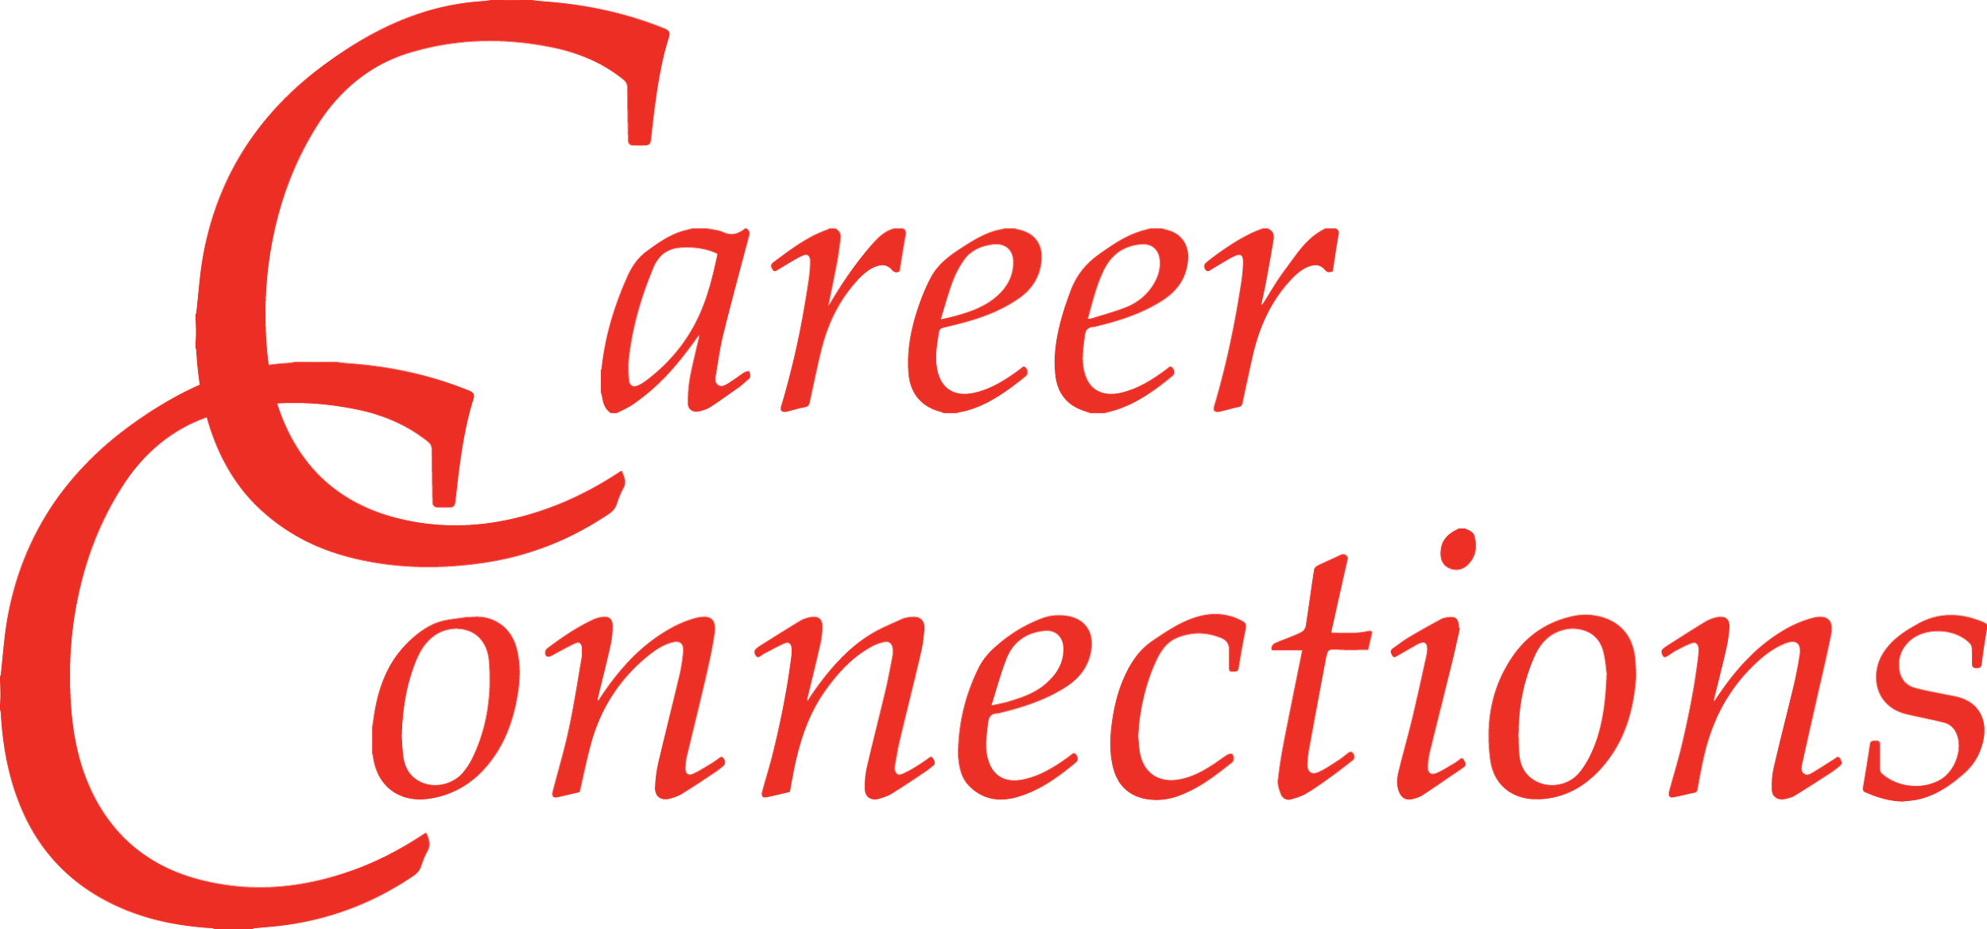

Preparation for your Future!
After you selected your 2 career clusters that you are interested in, please look at the careers in those clusters and answer the following questions:
Question | Response
List the careers you would like to learn more about at career connections? | 1.  2.  3.  4.
Review three company profiles, including videos, list the companies reviewed. | 1.  2.  3.
What types of careers do these companies have?
What careers do these companies have that interest you?
Post a discussion board question on Career Cruising to a company or to a specific areer that interests you. List that question in the right-hand box. | 1.
List 3 things you would like to learn at Career Connections. | 1.  2.  3.
Prepare 3 question you plan to ask at your career connections session: | 1.  2.  3.

